
Governing Body
Upper Beeding Primary School
School Road, Upper Beeding, BN44 3HY.
Tel: 01903 812288 Fax: 01903 816401
Email: ubpsgovernors@yahoo.com
Website: https://upper-beeding.eschools.co.uk/web

Chair: Mr N Pringle Clerk: Miss L Brown

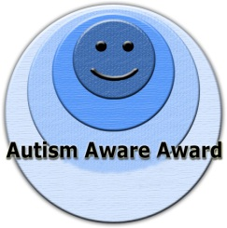
2013-2016
2013-2016
2013-2016
2013-2016
2013-2016
1st March 2017
Dear Parent

Election of Parent Governors at Upper Beeding Primary School

Every maintained school in England has a Governing Body responsible to the local community for running the school. The term of office for a Governor is 4 years.

Mrs Catherine Howe’s term of office is coming to an end very shortly. Mrs Howe will be standing again for Parent Governor, but if you are interested in standing for election as one of the Parent Governors of the school, please collect a nomination form from the school office. Please ensure that you obtain the signature of two parents/legal guardians of children at Upper Beeding Primary School who support your nomination. You must also include a brief election statement, and sign and return the declaration form. If two or more nominations are received, I shall send all parents voting papers, which will include the candidates’ election statements.

Nominations must be received in the school office by Wednesday 15th March 2017 at 10:00am

In the event of a ballot, I have arranged for votes to be counted at 10:30am on Wednesday 29th March 2017, and each candidate or his authorised representative may attend the count. I shall arrange for all parents to be notified of the result.

I have enclosed an extract from the Regulations concerning the qualification and disqualification connected with the office of Governor, which you should read carefully. If you have any queries about them or about the procedure, I shall be pleased to answer them.

All elected Parent Governors are required to complete an enhanced criminal record application within 21 days of their election.

Yours sincerely,

Becky Linford
Head Teacher
2013-2016
2013-2016
2013-2016
2013-2016

2013-2016

