**Reading with Your Y3&4 Child**

Parent Support Booklet

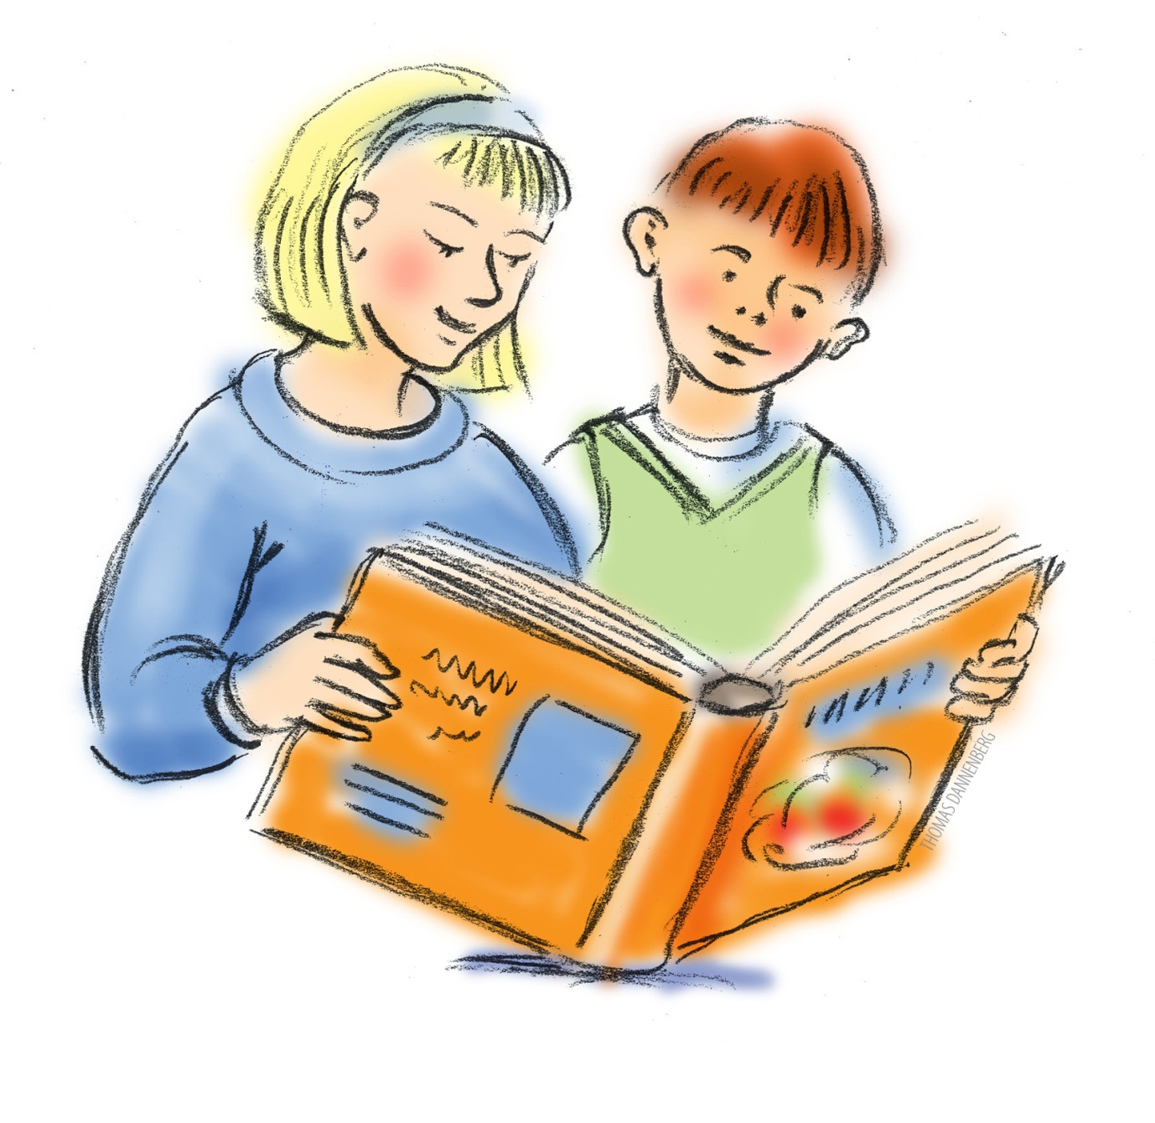

**National Curriculum Expectations**

**Year 3**

By Year 3, pupils should be able to read books written at an age-appropriate interest level. They should be able to read them accurately and at a speed that allows them to focus on understanding what they have read, rather than on decoding individual words. They should be able to decode most new works outside of their spoken vocabulary, making a good attempt at the word’s pronunciation. As their decoding skills become more secure, efforts should be made to introduce children to new words which will increase their vocabulary. This can be done through discussion and by introducing children to a wide range of text, including stories, poems, plays and non-fiction pieces on a wide range of subjects. They should be able to read these texts appropriately, fluently and enthusiastically and should be learning to read silently to themselves.

**What This Means for Parents**

* Allow your child to experience lots of books on many different topics.
* Encourage your child to attempt to pronounce new words they see on signs or within their environment and model the correct way.
* Broaden the vocabulary you use when speaking to your child and be prepared to clarify the meaning of a wider range of words.

**Year 4**

By year 4, pupils should be able to independently, fluently and enthusiastically read books written at an age-appropriate interest level. They should be able to read them accurately and at a speed that allows them to focus on understanding what they have read, rather than on decoding individual words. They should be able to decode most new words outside of their spoken vocabulary, making a good attempt at the word’s pronunciation. As their decoding skills become secure, efforts should be made to introduce children to new words which will increase their vocabulary. This should be done through discussion and by introducing children to a wide range of texts, including stories, poems, plays and non-fiction pieces on a wide range of subjects. Children in year 4 should be securing the skill of reading silently to themselves.

**What This Means for Parents**

* Give your child access to lots of books on many different topics and by a wide range of authors who write in different styles, e.g. Roald Dahl, Michael Morpurgo to Julia Donaldson.
* Encourage your child to attempt to pronounce new words they see in the environment around them. Discuss tricky parts and model the correct way.
* Broaden the vocabulary you use when speaking to your child and be prepared to clarify the meaning of a wider range of words.
* Encourage your child to read silently to themselves but check their understanding of what they have read after doing so

|  |  |
| --- | --- |
| **National Curriculum Reading Expectations** | **To support this, you could say…** |
| apply their knowledge of root words, prefixes and suffixes, both to read aloud and to understand the meaning of new words they meet | * Can you find a word which begins with the prefix dis-? * What does the prefix anti- mean? * So what could this new word mean? |
| develop positive attitudes to reading and an understanding of what they have read | * What happened in your story? * What kind of text would you like to read next? |
| listen to and discuss a wide range of fiction, poetry, plays, non-fiction and reference books | * What did you think about...? * Shall we go and watch a play about...? * Have you ever read a... poem? |
| use dictionaries to check the meaning of words they have read I’m not quite sure what it means either | * Shall we use a dictionary? |
| increase their familiarity with a wide range of books, including fairy stories, myths and legends, and retell some of these orally | * What genre is this text? * What happens in the story of...? * Do you know any myths? * Could you tell.... a bedtime story? |
| Identify themes and conventions within texts | * What message do you think this story is trying to tell us? |
| prepare poems and playscripts to read aloud and to perform, showing understanding through intonation, tone, volume and action | * Would you like to read a poem to us after dinner? * This part of the script is a troll speaking; how might they say it? |
| discuss words and phrases that capture the reader’s interest and imagination | * What an interesting use of words; why do you think the author chose those? |
| recognise some forms of poetry, e.g. free verse, narrative poetry | * Do you know what kind of poem this is? * What can you see? |
| check that the text makes sense to them | * What do you think that is saying? |
| explain the meaning of new words in context | * What does... mean? I’m not quite sure. I thought it meant... |
| ask questions to improve their understanding of the text | * Is there anything you want to ask that you’re not sure about? |
| draw inferences, such as inferring characters’ feelings, thoughts and motives | * How do you think... is feeling? * What makes you think that? * Why did he make that choice? |
| predict what might happen from the details stated and implied | * If they...., what might they do next? * Who could it be? * What makes you think that? |
| identify the main ideas drawn from more than one paragraph and summarise these | * So, what has this part of the story been about? * Have you spotted a theme in the story? |
| identify how language, structure and presentation contribute to meaning | * Why do you think the author has used... in the text? |
| retrieve and record information from non-fiction texts | * Can you find the part where...? * Which part tells you about...? |
| participate in discussion about both books that are read to them and those they can read themselves, taking turns and listening to what others say | * Would you like me to read this page? * What did you think of...? I thought that... * Do you think... would like this book? What makes you think that? |

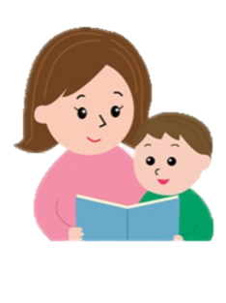

**Further questions to help children with their reading**

**Questions about Vocabulary**

* What does this word/phrase/sentence tell you about the character/mood/setting?
* By writing this way what effect has the author created/did the author intend to create?
* How has the author made you/the character feel happy/sad/angry/frustrated?

**Retrieving text**

* 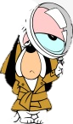Where / when does the story take place?
* Find evidence in the text. Where in the text would you find...?
* Which part of the story best describes...?

**Summarising**

* 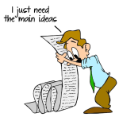What is the main point in this section of the text?
* Recap what has happened so far in 20 words or less.
* Which is the most important point in this paragraph? Is it mentioned anywhere else?

**Making Inferences**

* What do these words mean and why might the author have chosen them?
* Can you explain why...?
* Which words give you the impression that...?

**Making predictions**

* Can you think of another story with a similar theme/opening/ending?
* Why did the author choose this setting?
* Will it influence how the story develops?
* How is this character like someone you know in real life? Will they act in the same way?