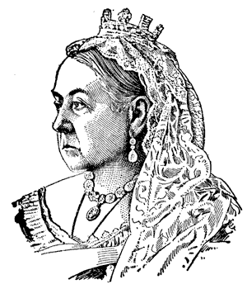.

**Science**

* Forces including; gravity, air and water resistance and friction
* Levers, gears and pulleys

**PSCHE**

* Dreams and Goals
* Healthy Me

**PE**

* Netball – passing, defending, attacking
* Hockey – shooting, passing, dribbling
* Swimming – Morocco Class

**Computing**

Developing an interactive game using Scratch coding and designing a website

**English**

* Exploring texts: ‘Street Child’ by
* Berlie Doherty
* Persuasion letters: Applying for jobs at Preston Manor
* Information leaflet exploring life in Victorian times.
* Writing an argument: The Highwayman, Who killed Bess?
* Exploring poetry from the Victorian era

**Music**

* 10 pieces

(BBC national project)

**Technology**

* Designing and making a toy based on a CAM mechanism

**History and Geography**

* Key events in the Victorian era
* Exploring what it was like in a Victorian classroom
* Looking at Victorian artefacts
* Exploring census returns and local maps from the Victorian period

**The**

**Victorians**

**RE**

* Christianity: Is anything ever eternal?
* Christianity: Does participating in worship help people to feel closer to God or their faith community?

|  |
| --- |
|  |

**Mathematics**

* Fractions, decimals and percentages
* Multiplication and division (Year 5)
* Measurement (Year 6)
* Algebra and ratio
* (Year 6)
* Geometry (Year 6)
* Statistics (Year 6)

**Visits**

* Victorian Day (Monday 7th January)
* Preston Manor

(11th and 12th March)

**Art**

* Looking at the work of William Morris
* Exploring printing techniques to recreate a wallpaper/fabric design

**Topic Overview 2019**

Exploring what it was like in a Victorian classroom

Looking at Victorian artefacts

Exploring census returns and local maps from the Victorian period