Adjectives  Describing words | Nouns  A naming word |  | Adverbs  More information about the verb | Co-ordinating Conjunctions | Subordinating Conjunctions
Usually found before a noun  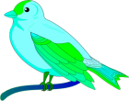  The little bird sat on the leafy branch. | Common – everyday objects  Proper – starts with a capital letter i.e. June, Friday, English  Collective – group e.g. choir, team, class    Abstract – idea/emotion i.e. hope, beauty, anger |  | (adjective turn to adverb – usually ends with an ‘ ly’).  The girl played the piano softly.  The children shouted loudly.  Also expresses time, place and cause: then, next, soon, therefore | A conjunction links words or groups of words.  A coordinating conjunction joins two main clauses  REMEMBER FANBOYS  for, and, nor, but, or, yet, so     | A subordinating conjunction is also another joining word  Bella repainted her room because she didn’t like pink anymore.  I will pick you up at 9pm although that is later than I would like.
Pronouns  Replaces a noun to avoid repetition | Prepositions  Come before a noun |  | Determiners  Comes before a noun | Present Perfect  Verb to show something that happened and continues in the present. | Noun phrases  A phrase with a noun as its main word
The bird pecked the apple and ate it as he sat on a branch.  Key words: I, me, you, he, she, we, us, they, it | Usually comes before a noun or pronoun. They often describe position or time.  The dog was sleeping under the bed. (position)  I haven’t eaten since my breakfast this morning. (time) |  | Articles: the, an, a  Possessive pronouns: his, her, my, our, their, your, its  Quantifiers: every, much, some, many, few, each | Key words: ‘has’ and ‘have’  with the past tense of the verb.  The band has left the stage.  I have gone to work. | It does not contain a verb (action word):    The fierce angry lion  with razor sharp teeth.
Sentences |  |  | Fronted Adverbials  Found at the ‘front’ of the sentence | Possessive pronouns These tell you who / what owns the noun: | Tenses  Past tense: it has happened  The boys played football in the park.  Present: it is happening now  The boys are playing football in the park.  Future: it will be happening in the future  The boys will play football tomorrow.
  Statement: tells you something e.g. I love seeds.  Question: asks you something e.g. Should I eat those seeds?  Command: tells you to do something e.g. Take these seeds away!  Exclamation: exclaims about something e.g. What delicious seeds these are! |  |  | Used to describe the action that follows.  Before the sun came up, he ate his breakfast. | The bird pecked his apple as he sat on a branch.  Key words: my, yours, his, her, ours, their its
Main Clause  This makes sense on its own. |  | Subordinate Clause  This doesn’t make sense on its own | Past Progressive  The action was happening (past). | Present Progressive This tells us that the action is happening
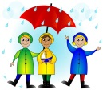  Despite the bad  weather, the children  went out to play. |  | It needs the main clause.  Despite the bad weather, the children went out to play. | Will was kicking the ball.  The girls were baking a cake. | …and will continue to do so.    I am walking  he is sleeping  they are baking

PUNCTUATION   | Capital letters | Apostrophes (‘) | At the end of a sentence
 | 1) Go at the beginning of a sentence:  The warm and sunny day.  2) Proper noun: names of people, places, days of the week: Mary, Friday, June, London, German    3) Personal pronoun ‘I’ | 1) Singular possession: Sally’s bag.  2) Plural possession: The boys’ football.  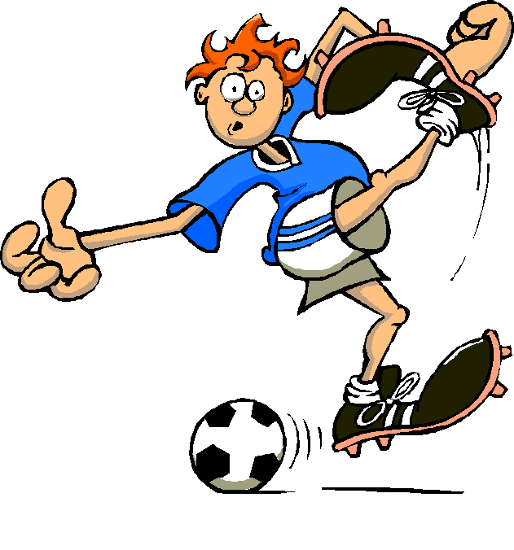  3) To mark contractions (missing letters): don’t (do not), won’t (will not)  4) its (pronoun) / it’s  (contraction for ‘it is’) | a) Full stop – ends a statement:  For example: I like swimming.  b) Question mark – put at the end of a question e.g. Where are you?  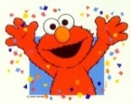  c) Exclamation mark: to show something urgent, surprising or anger!  e.g. It’s a goal!
Prefixes | Suffixes | Inverted Commas | Word families
A group of letters that can be added to the beginning of a root word: im, re, dis, sub, un, pre, ex, co, anti, bi, over, inter  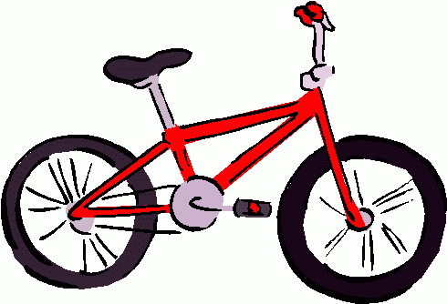  e.g. submarine, impolite, discourage, bicycle | A group of letters that can be added to the end of a root word: ness, able, less, ful, ed, er, ize, ly    e.g. happily, careful, walked, energize, bigger | Inverted commas or speech marks are used to show direct speech.  Gemma asked her brother if he wanted a bag of crisps becomes: Gemma asked her brother, “Would you like a bag of crisps?”   | Word families are related to each other by spelling, grammar and meaning.  medicine, medical, medic  noise, noisy, noiseless  photograph, photographer  apply, applicant, reapply, application
Commas (,)
Commas have a range of uses within a sentence. Here are some examples…

Used to separate items in a list e.g. Sam packed his P.E. bag with: a t-shirt, shorts, long socks and trainers.

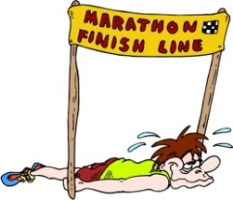
Used to clarify meaning : I went to the cinema with my friend Sally and Thomas (which suggests that I went to the cinema with Sally (who is my friend) and Thomas whereas I went to the cinema with my friend, Sally and Thomas suggests that I went to the cinema with a friend, Sally and Thomas.

Commas after fronted adverbials: Panting with exhaustion, Tim crossed the finishing line.

Mark a short pause: He was, however, too tired to make the trip.

